**Power BI Project: Global Health Expenditure Analysis**

**__________________________________________________**

## **Overview**

In this Power BI project, we will analyze global health expenditure data to gain insights into different aspects of health spending across countries and regions. The dataset used in this project will contain information on health expenditure, GDP, population, and other relevant metrics.

## **Objective**

The objective of this Power BI project is to analyze global health expenditure data to gain valuable insights into various aspects of health spending across countries and regions. The primary goal is to provide a comprehensive and data-driven view of health expenditure trends, and their relationships, and identify key patterns. The analysis aims to answer critical questions and support decision-making in the field of global healthcare

**Data Source**: We will use a dataset that includes the following key columns:

* ***CountryID:*** It contains unique identifiers to different countries
* ***Country:*** Name of the country or region.
* ***YearID:*** It contains unique identifiers to different years
* ***Year:*** Year of the data record.
* ***Health Expenditure:*** Total health expenditure in US dollars.
* ***GDP:*** Gross Domestic Product in US dollars.
* ***Population:*** Total population of the country or region.

## **Project Steps**

**—-----------------------------**

1. **Data Loading and Data Modelling:**
   * Imported the dataset into Power BI.
   * Performed data cleaning and transformation as needed.
     + Removed Blank Rows
     + Used First Row As Header
     + Rows With Error Values Removed
     + Checked Column Quality,Distribution & Profile

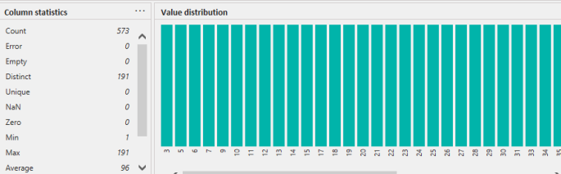

* + Created a data model with appropriate relationships between tables (if multiple tables are used).

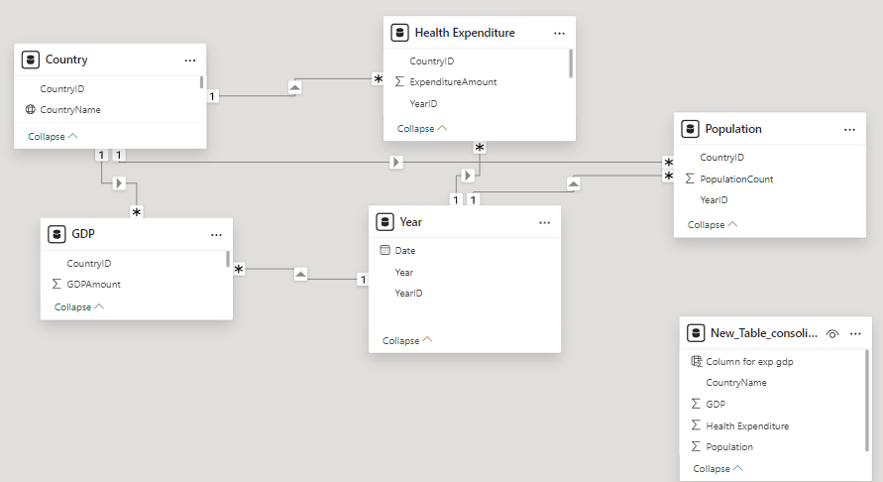

* + Ensured that all relevant columns have appropriate data types.

1. **Data Analysis using DAX Functions:**

Q1) Create a new table that consolidates information from multiple tables using DAX. Created the table using Summarize Function

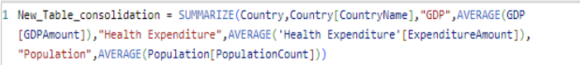

Q2) Find the countries with highest and lowest health expenditure for all years.

● Calculated Max and Min health expenditure using Max & Min Functions.

● Filtered the visualization as Top 1 value placing Country Name in the column field to display country name

● Used Text Card for visualization

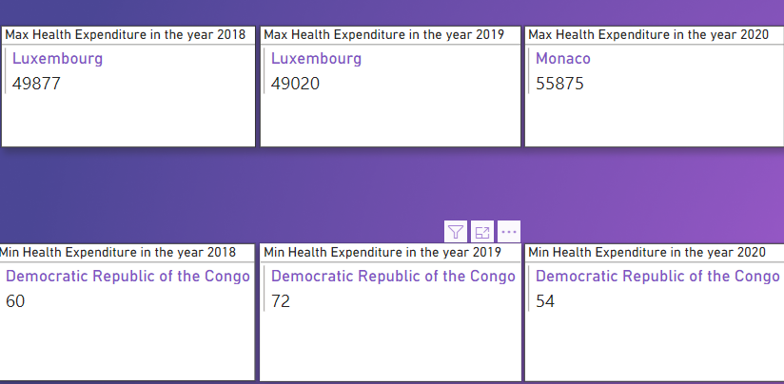

Q3)Determine the percentage of health expenditure as a share of GDP for each country.

● Created a measure which divides the sum of health expenditure with gdp.

● Kiribati tends to have the highest percentage of health expenditure as a share of gdp resulting in 127%.

● Haiti has the lowest percentage resulting in 10%

● Used a Clustered bar chart for visualizations

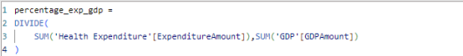

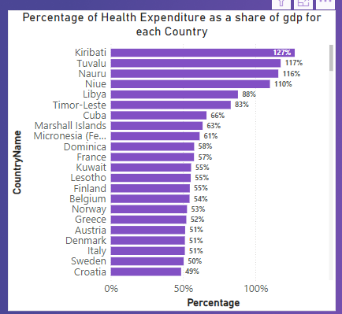

Q4) Calculate the average health expenditure per capita for each country.

● Created a measure which divides total expenditure with total population of each country.

● Niue has the highest per capita health expenditure amounting to $8954.

● India has the lowest per capita health expenditure.

● Used a clustered Bar chart for visualizations.

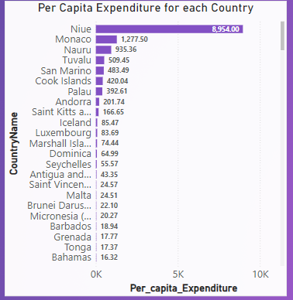

1. **Visualizations:**

Q1)Calculate the year-to-year percentage change in health expenditure.

● Created a measure to calculate year-to-year change in percentage.

● Used a line chart to display the change

● As the data contains information for three consecutive years,the visualization displays -0.12% for 2018-to-2019 and 10.3% for 2019-to-2020.

● Placed a slicer for custom filters.

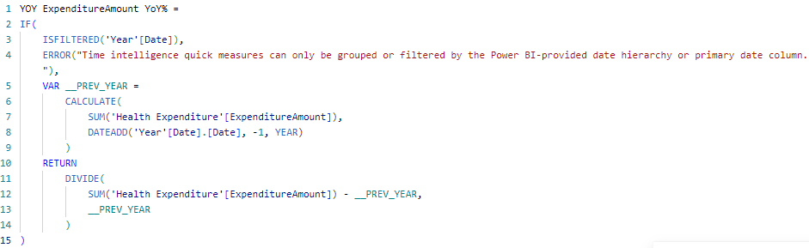

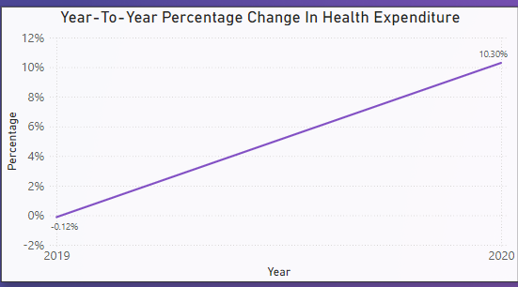

**Insights:**

The Change in Percentage from 2018 to 2019 is -0.12% and from 2019 to 2020 is 10.3%.The year 2020 has High expenditure and more change in percentage.

Q2) Calculate the average annual growth rate of health expenditure over a selected period. Assumption: Assuming the period to be 2019 to 2020

● Created a measure which calculates the % difference from 2019-to-2020

● Used a Text Card to display the value

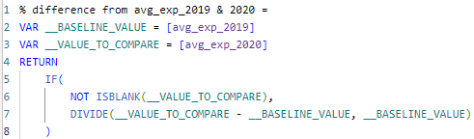

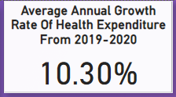

Q3) Create a line chart to visualize the trend of health expenditure over the years for selected countries/regions.

● Used a line chart to display the trend

● Placed year column on the x-axis and average expenditure amount on the y-axis

● Placed a slicer for custom filters.

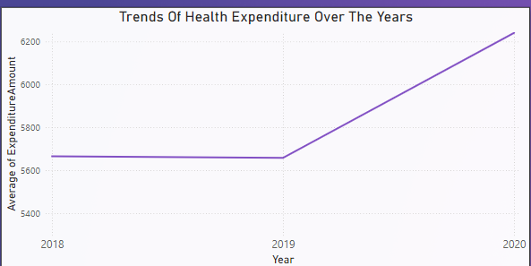

Insights:

1. The **average health expenditure** increased from **5665.03 in 2018** to **5658.44 in 2019**, showing a slight decline of **0.12%**.
2. In **2020**, the **average expenditure rose to 6241.34**, marking a **10.3% increase** from 2019, the highest among the three years.
3. The **total health expenditure** was **1,082,020 in 2018**, **1,080,762 in 2019**, and **1,192,096 in 2020**, indicating a growth trend.
4. **2020 accounted for 35.53% of total health expenditure**, the highest share compared to previous years.

Q4) Create a bar chart to compare health expenditure across different countries for the year 2020

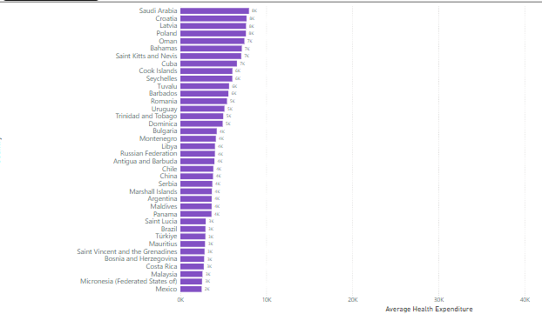

**Insights:**

Across all 191 CountryName, average expenditure ranged from 54 to 55875. At 55875, Monaco had the highest average expenditure and was 1,03,372.22 higher than Democratic Republic of the Congo, which had the lowest expenditure amounting to 54.

Q5) Use a scatter plot to explore the relationship between health expenditure and GDP.

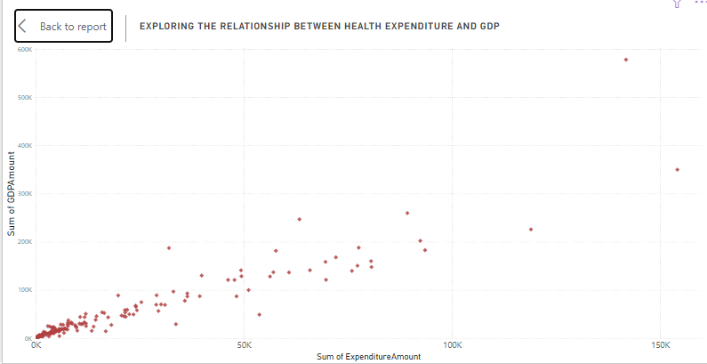

**Insights:**

Across all 191 countries Luxembourg had the highest Sum of ExpenditureAmount (154152) and Monaco had the highest Sum of GDPAmount (578282). Analyzing the relation between GDP and Expenditure,lower the GDP less is the expenditure so they are directly proportional.

Q6) Map Visualisation to Show Health Expenditure Distribution Geographically.

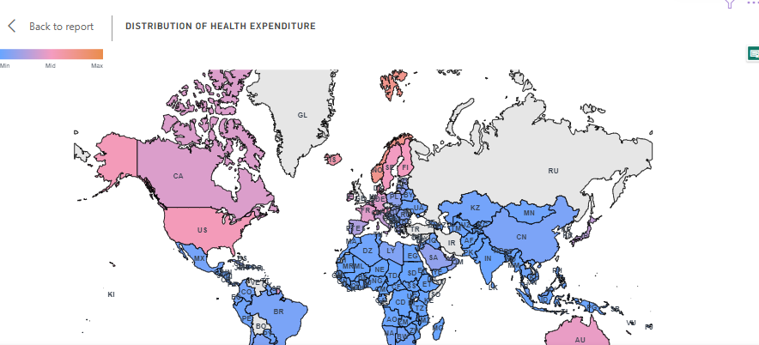

**DASHBOARD**

